 |  | OPERATING INSTRUCTIONS  Workplace:  Chair:  Responsible person:  Creator: | Status:  05.2019
SCOPE
Sample operating instructions for handling hazardous substances
For trained employees only

HAZARDS TO HUMANS AND THE ENVIRONMENT
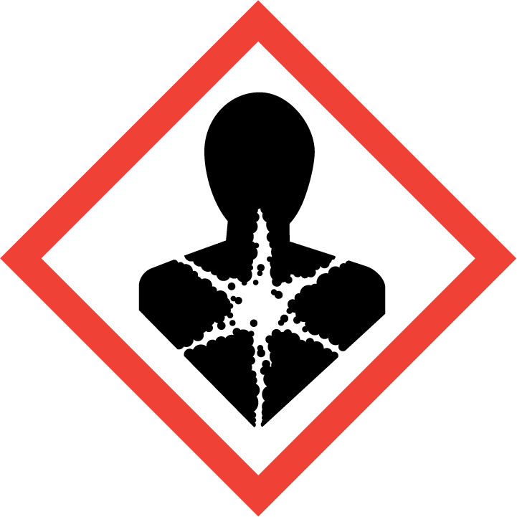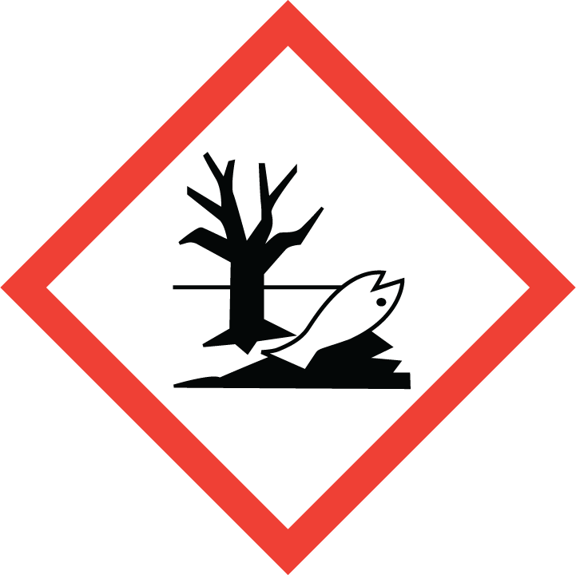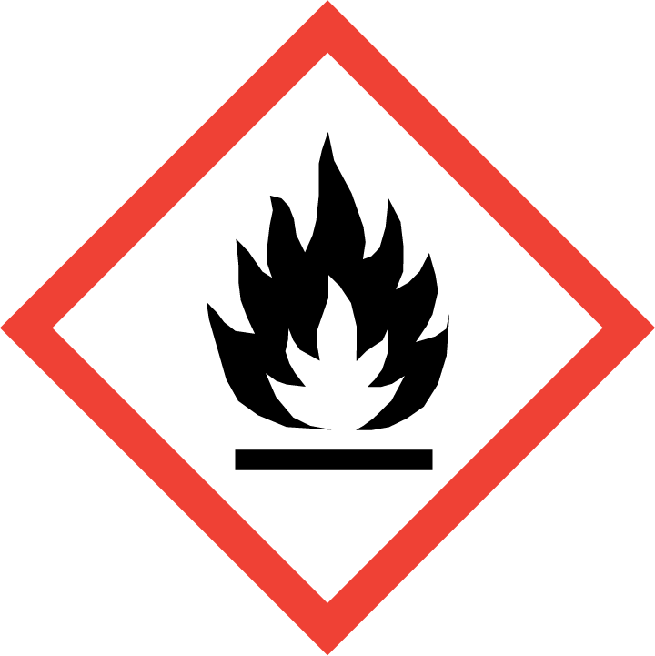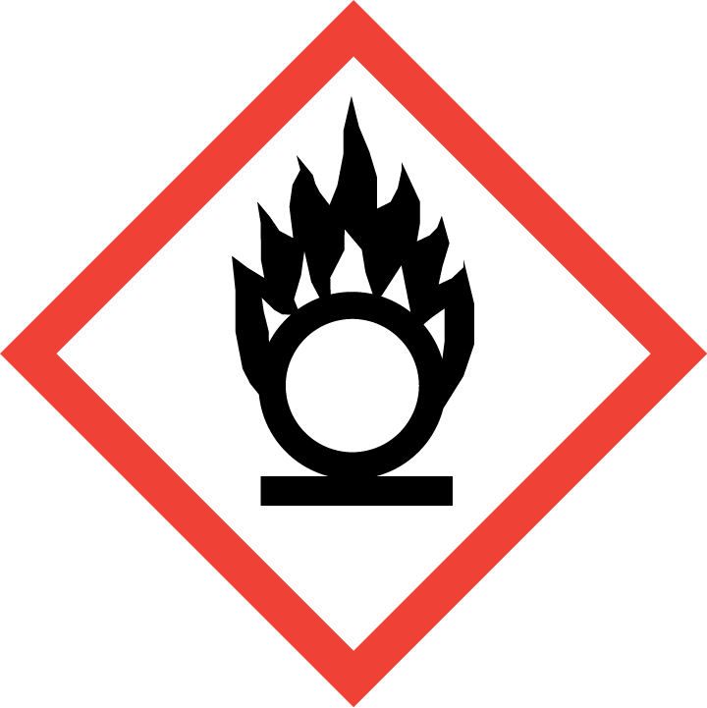 |  |  |  | 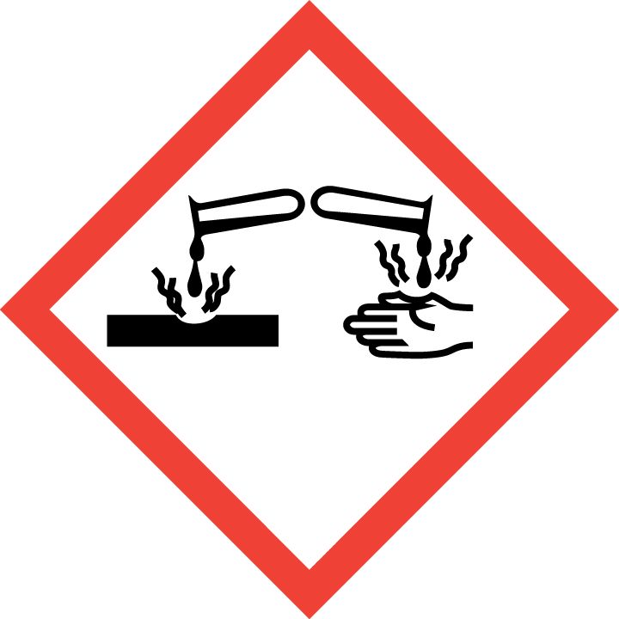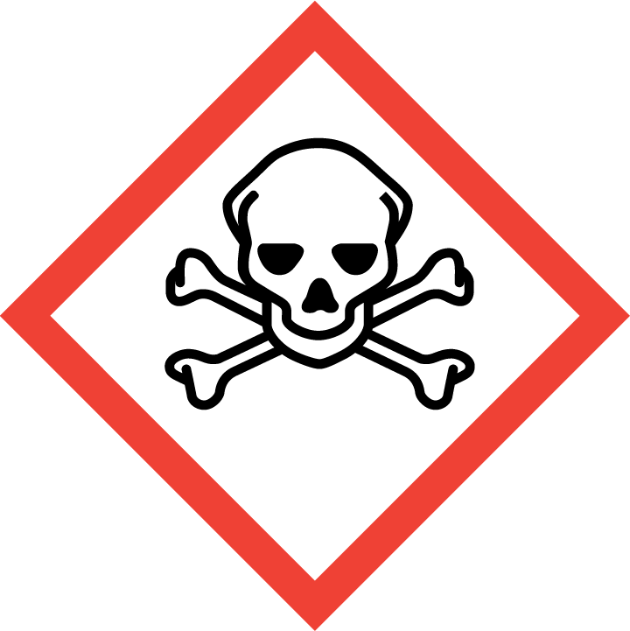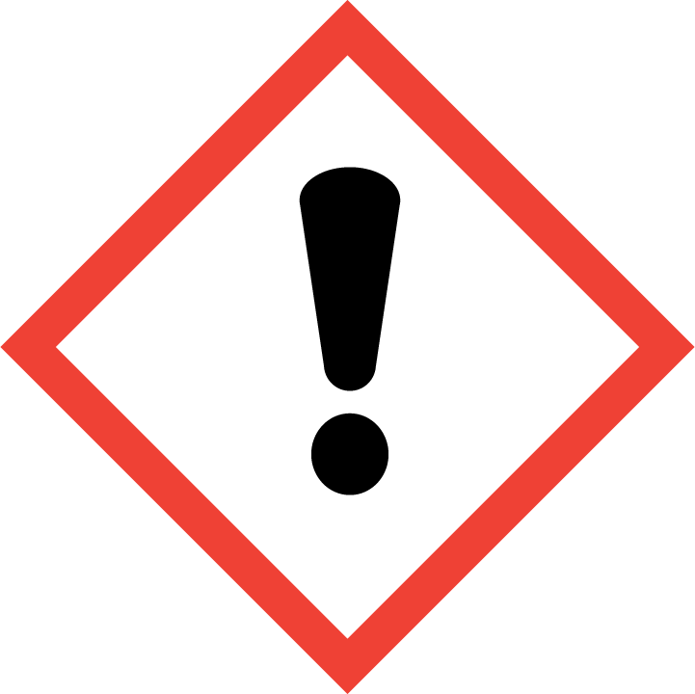
PROTECTIVE MEASURES AND RULES OF CONDUCT
 | - No smoking, eating, or drinking.  - The name of the substance, hazard symbols, and warning notices must be displayed on the containers.  - Suitable protective clothing (e.g., lab coat, safety goggles, etc.) must be worn.  - When handling gaseous, dusty, or highly volatile substances,  Technical protective equipment (laboratory fume hood, extraction system, etc.) must be used. |  |  | 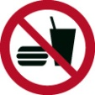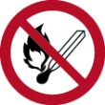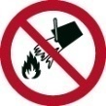
BEHAVIOR IN THE EVENT OF MALFUNCTIONS
- Release:
- Remain calm, warn endangered persons, and instruct them to leave the premises.
- Inform supervisor(s).
- Extinguishing/absorbent materials:

ACCIDENTS / FIRST AID
  0-112 Emergency  3333 Control room | - Ingestion: Give small sips of water to drink. Avoid vomiting!  - Eye contact: Use eye wash. Rinse for several minutes with eyelids open.  - Skin contact: Use emergency shower, rinse thoroughly with water for several minutes.  - Consult a doctor. Have the safety data sheet ready.  - First aider:
TESTS / MAINTENANCE / DISPOSAL
- Disposal: Hazardous substances must be reported to the central disposal office of TU Dortmund University in appropriate containers and with a declaration.
- Information on proper disposal can be obtained from Referat 7 (tel.: -3309 or -7521).
Pictograms for operating instructions, source: BGHM
Mandatory signs, prohibition signs, warning signs,
hazardous substance designation

 |  |  |  |  | 
 |  |  |  |  | 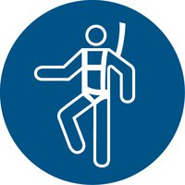
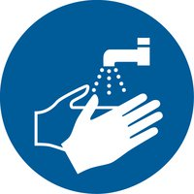 | 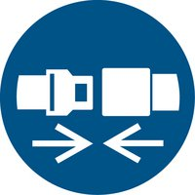 |  |  |  | 

 | 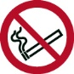 | 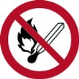 |  | 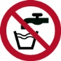 | 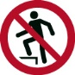
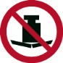 |  |  | 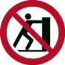 |  | 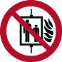
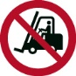 | 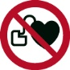 | 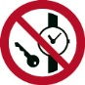 | 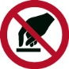 | 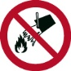 | 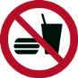
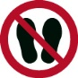 | 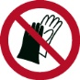 | 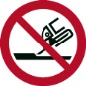 | 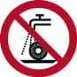 |  | 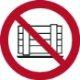
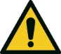 | 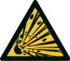 | 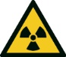 | 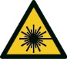 | 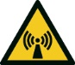 | 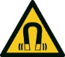
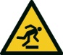 |  | 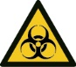 | 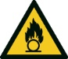 | 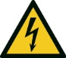 | 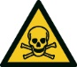
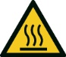 | 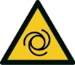 | 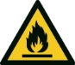 | 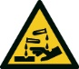 | 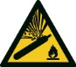
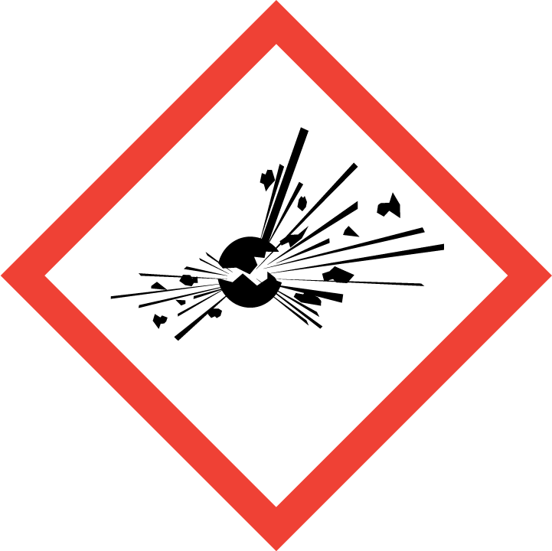 |  |  | 