 |  | OPERATING INSTRUCTIONS  Workplace:  Chair:  Responsible person:  Creator: | Status:  05.2019
SCOPE OF APPLICATION
Sample operating instructions for working with machines
Only for trained employees

HAZARDS TO PEOPLE AND THE ENVIRONMENT
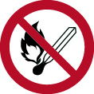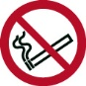 |  |  |  | 
PROTECTIVE MEASURES AND RULES OF CONDUCT
 |  |  |  | 
BEHAVIOR IN THE EVENT OF MALFUNCTIONS
ACCIDENTS / FIRST AID
  0-112 Emergency number  3333 Control room | - Inhalation:  - Eye contact:  - Skin contact:  - In case of injury, make an entry in the first aid log.  - First aider:
INSPECTIONS / MAINTENANCE / DISPOSAL
- Regular inspection intervals:
- Disposal:

Next inspection date: Signature of responsible person:

Pictograms for operating instructions, source: BGHM
Mandatory signs, prohibition signs, warning signs,
hazardous substance designation

 |  |  |  |  | 
 | 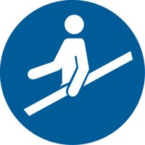 |  |  |  | 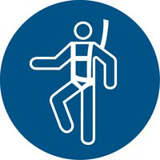
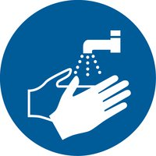 | 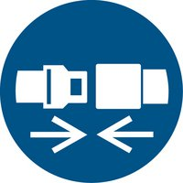 | 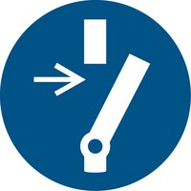 |  |  | 

 |  | 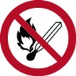 | 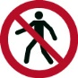 | 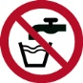 | 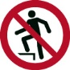
 | 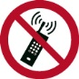 |  | 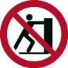 | 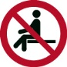 | 
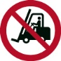 |  | 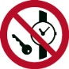 |  | 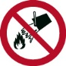
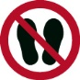 |  | 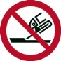 |  |  | 
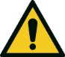 | 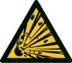 | 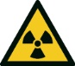 | 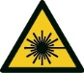 | 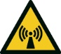 | 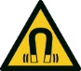
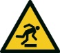 | 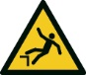 | 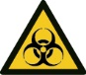 | 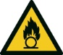 | 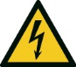 | 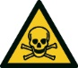
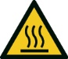 | 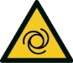 |  | 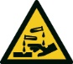 | 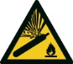
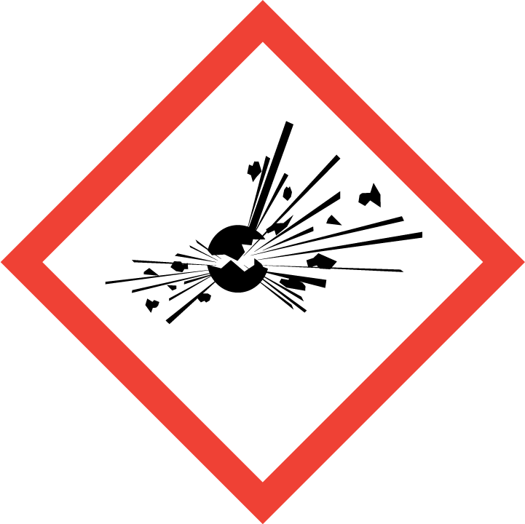 | 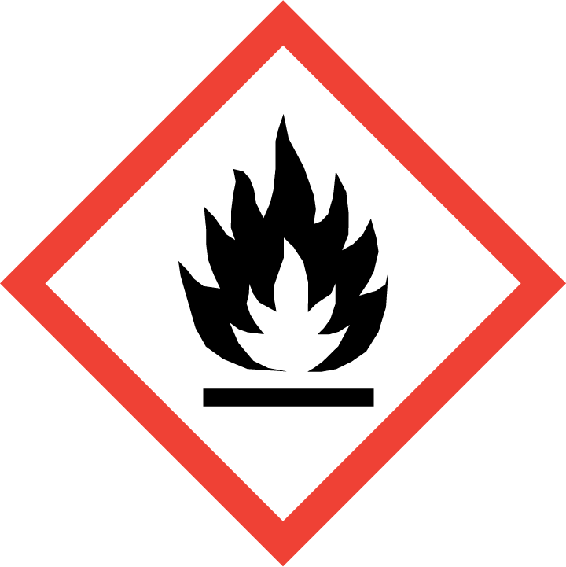 | 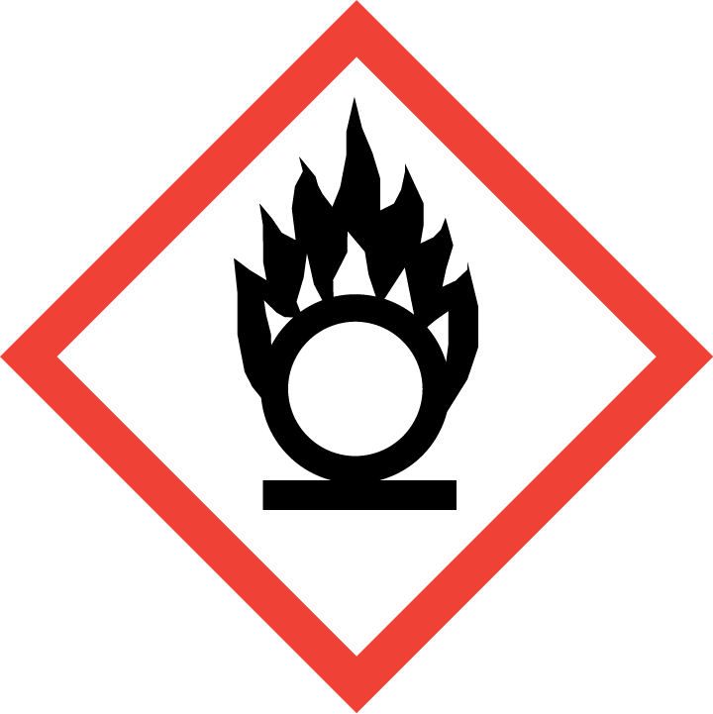 | 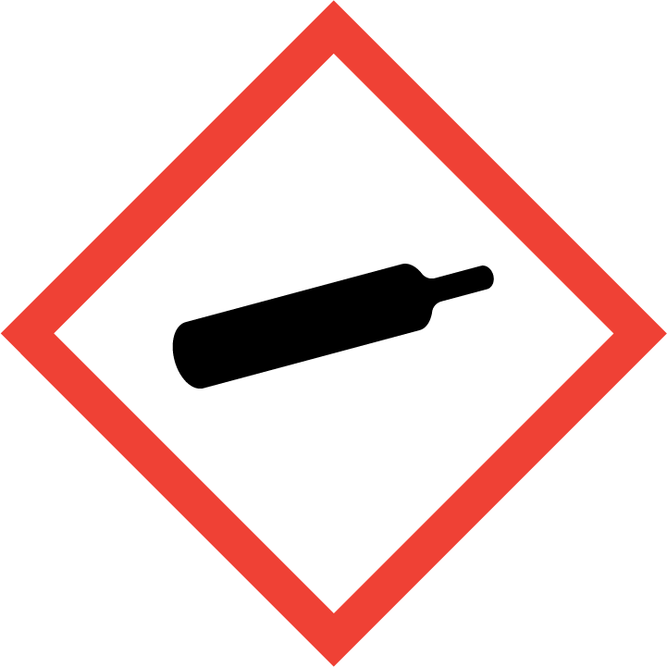 | 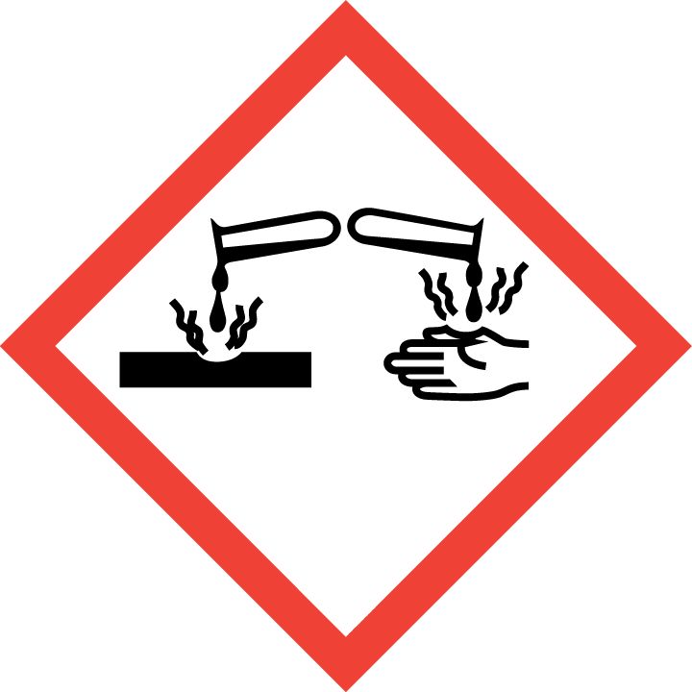 | 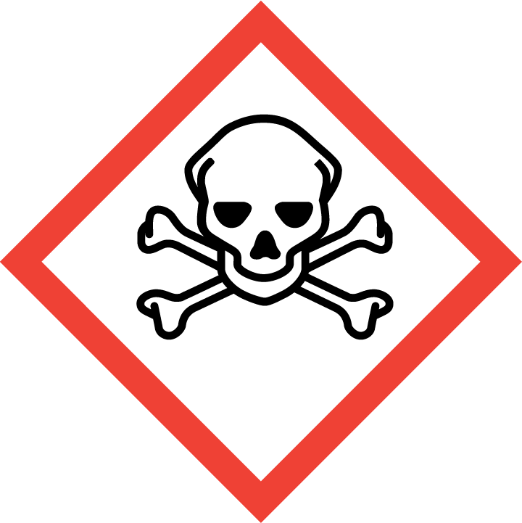
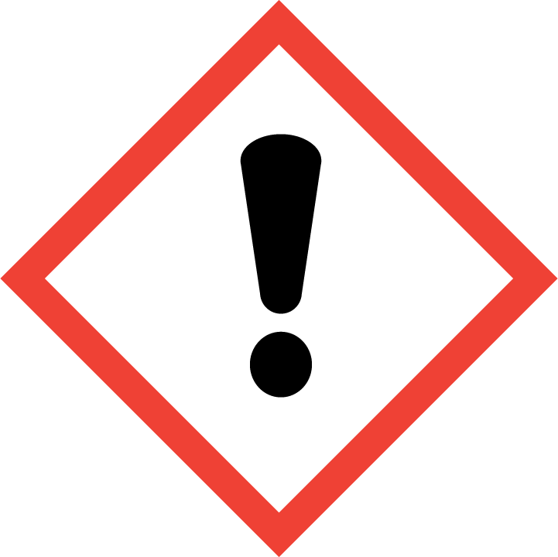 | 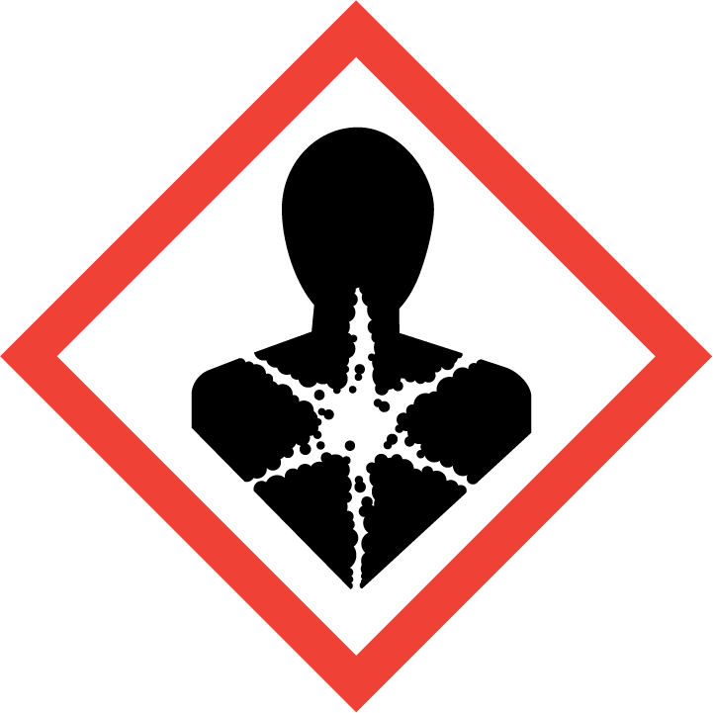 | 